**HIVE ASSIGNMENT**

1. Use Database

**Command**: use Pradul;

2. Create Table

**Command**: create table movies(sl_no INT,movie_name STRING,year INT,ratings FLOAT,reviews INT)row format delimited fields terminated by ',' stored as textfile;

3. Load Data

**Command**: load data INPATH '/user/cloudera/ust/movie.csv' into table movies;

4. Display Table

**Command**: select * from movies limit 10;

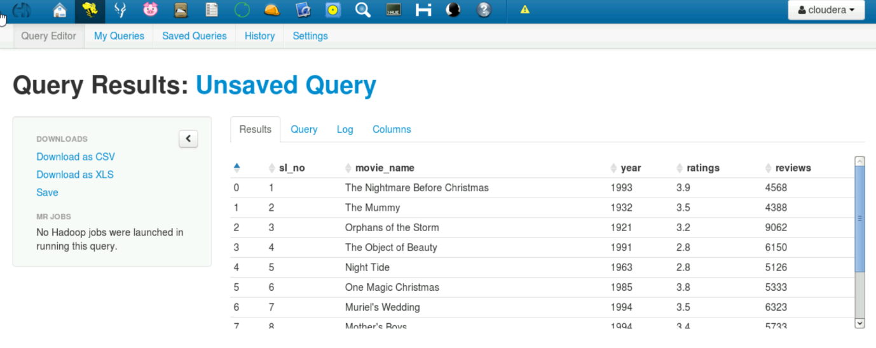

**ASSIGNMENT COMMANDS:**

1. The number of movies released between 1950 and 1960.

**Command**: select count(movie_name) AS Movie_Count from movies where year BETWEEN 1950 AND 1960;

1. The number of movies having rating more than 4.

**Command**: select count(movie_name) AS Movie_Count from movies where ratings > 4;

1. The movies whose rating are between 3 and 4.

**Command**: select movie_name AS Movie_Names from movies where ratings BETWEEN 3 and 4;

1. The number of movies with reviews more than 7200.

**Command**: select count(movie_name) AS Movie_Count from movies where reviews > 7200;

5. The list of years and number of movies released each year.

**Command**: select year,count(movie_name) AS Movie_Count from movies GROUP BY year ORDER BY year DESC;

6. Total number of movies in dataset.

**Command**: select count(movie_name) from movies;

